Balance sheet terms in English

### **1. Accounts Payable**

*“We currently have a large****accounts payable****list to our suppliers.”*

Money that is *owed* *by* the business to its suppliers. This is shown up as a liability in the balance sheet.

### **2. Accounts Receivable**

*“You should be constantly aware of how inflation can discount your****accounts receivable****.”*

Money that is *owed to*the business by its customers. This is for goods or services that have been delivered but have not yet been paid.

### **3. Assets**

*“He has****assets****in the form of stocks, mutual funds, and property.”*

An item that a company or person owns that has monetary value. These come in the form of tangible assets (typically physical assets owned by the company, such as property, equipment and land) and intangible assets (assets not physical in nature, such as patents, copyright, goodwill and trademarks).

### **4. Book Value**

*“The proposed purchase price is approximately two times the****book value****.”*

The total value of a business’ assets found on the balance sheet. This number represents the total value of all of the assets a company owns if they are liquidated (sold to generate cash).

### **5. Equity**

*“When the company collapsed, its****equity****was wiped out.”*

The remaining value of a company after all liabilities have been removed. Equity is the portion of a company owned by its investors and shareholders. It can be calculated as Assets – Liabilities.

### **6. Inventory**

*“The company is managing to market and sell its products, keeping****inventory****low.”*

Inventory represents a company’s goods that remain unsold to its customers. [**Inventory management**](https://www.shipbob.com/blog/order-management/) is typically counted within three stages of production: raw goods, in-progress goods and goods that are ready for sale.

### **7. Liabilities**

*“The company has enough money to cover its existing****liabilities****.”*

Any debts that a company has yet to pay. Whereas **accounts payable** is money owed only to suppliers, liabilities can include money that a business also owes to staff, as well as loans, mortgages and bonds.

## Income statement (Profit and Loss) terms in English

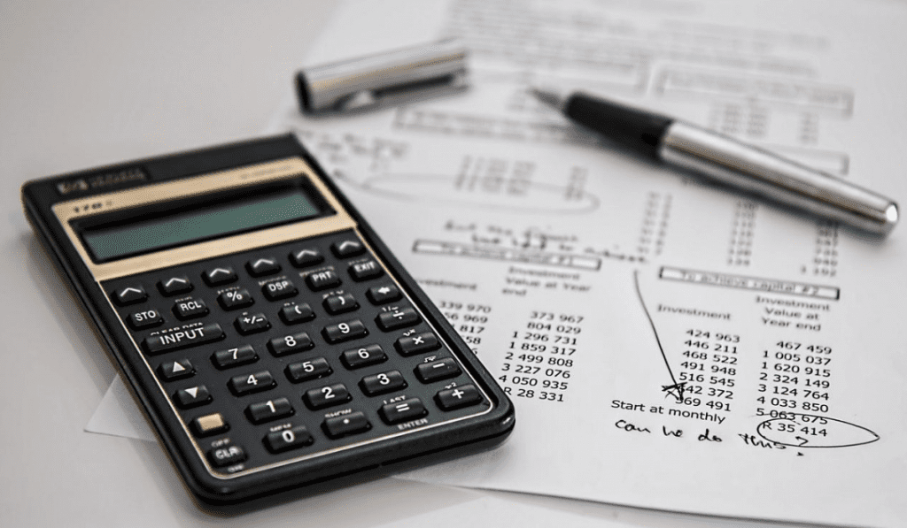

The Income Statement (or Profit and Loss Statement) is the second of the two most common financial reports. It shows the revenue, expenses, and net income or loss over a period of time.

### **8. Cost of Goods Sold**

*“Ikea’s****cost of goods sold****fell by 3% in the last quarter.”*

The cost of production for the goods sold by a company. This number includes labor costs and the raw materials used to create the goods. Indirect expenses such as the transport of goods are excluded from this cost.

### **9. Depreciation**

*“The company was hurt by high****depreciation****costs.”*

Depreciation is when an asset loses value over time. Depreciation commonly happens when  physical assets break or wear out, such as when an office computer gets damaged, a machine breaks down, or a building starts to decay. Land is the only physical asset that appreciates (increases in value) over time.

### **10. Expenses**

*“Many companies shut down during the weekend to save on****expenses****.”*

Expenses are money spent by a business in order to generate revenue. Expenses are the sum of all activities that a business is using to try and reach a profit. These are split into fixed expenses, set amounts that a business has to pay regularly (rent, salaries, wages) and variable expenses, which might cost more or less depending on external factors (advertising, commission, utility bills).

### **11. Gross Profit**

*“****Gross profit****is at its highest level in more than 3 years.”*

The total amount of profit a company makes after subtracting the costs associated with making and selling its products. When gross profit is calculated, the costs of overheads like rent, travel costs and advertising are not subtracted.

### **12. Net Income**

*“Apple had set records in both sales and****net income****figures.”*

The amount that is earned by a business in profits, after all costs are deducted. It is calculated by taking revenue and subtracting all of the expenses within a period of time, including overheads, depreciation, and taxes.

### **13. Revenue (Sales)**

*“The football club estimates that it will reach a record annual****revenue****of $600 million.”*

The income a business makes from its activities, before subtracting any expenses. This usually comes in the form of sales and services to customers. Revenue is also referred to as “sales” or “turnover”.

## General accounting terms in English



There are some accounting terms in English that aren’t linked to the balance sheet or income statement, but are still essential to know. Take a look below to learn the most important general accounting English terms.

### **14. Cash Flow**

*“A strong brand identity, great management and positive****cash flow****are essential for your company to be a market leader.”*

Measures how much money is moving into and out of a business during a period of time. A company will create more value for its shareholders by generating positive, long-term cash flow. A company will create negative cash flow by spending more money that it makes over a specific period of time.

### **15. Credit**

*“The danger with****credit****card debt is the increases in interest are incremental.”*

When used as a noun, “credit” records a sum of money received by a business, and is listed on the right-hand column of an account. A company’s credits and debits will always equal each other, ensuring the balance sheet and income statement are always in balance and accurately reflecting the income, expenses, assets, liabilities and equity within a business.

An example of a credit is an increase in liabilities that will be paid at a later date. Many people and companies buy “on credit” via the use of credit cards, when they do not have enough cash to make the purchase and wish to pay the cost at a later date.

### **16. Debit**

*“Your account will be****debited****for the cost of your insurance every month.”*

When used as a noun, “debit” records a sum of money owned by a business, and is listed on the left-hand column of an account. An example of a debit is the purchase of a new computer, which is an additional asset.

However, debit can also be used as a verb, meaning when a bank or financial organization removes money from a customer’s account. This is most commonly achieved via the use of a debit card.

### **17. Diversification**

*“The company was looking into****diversification****to generate new sources of revenue.”*

A technique of allocating resources and investing time, money and energy into different activities. For example, a company may decide to diversify by expanding into new markets or producing new products.

### **18. Fixed Cost**

*“The business is reducing****fixed costs****, continuing to grow and balancing growth and profitability.”*

Business costs that remain the same, no matter the amount of goods produced. Examples of fixed costs include rent, salaries and certain taxes.

### **19. Forecasting**

*“After analyzing the accounts of the last few years, he was****forecasting****a challenging Q3 for the business.”*

The act of using past data to predict future costs, growth and financial trends. Businesses use  forecasting to help them plan for upcoming expenses, and decide how to allocate their budget within a set period of time.

### **20. Interest**

*“The loan carried a very high****interest****rate, so I did not take it.”*

Interest is a fee for borrowing an asset. It can be considered an expense to the borrower and income to the lender. Interest is essentially compensation for the asset or service that is lent.  This number is usually calculated as a percentage of the amount of money borrowed, and is added onto the cost of future repayments.

### **21. Liquidity**

*“The business believed that this change will result in improved****liquidity****and profitability.”*

The ability to get your hands on money, whenever it is required. Cash and savings are “liquid assets” because they can easily be changed into cash very quickly. Non “liquid assets” include property and machinery, which cannot be changed into cash quickly.

### **22. Overhead**

*“The business had lowered its****overhead****costs by canceling their rental lease and working entirely remotely.”*

A consistent cost of running a business. Overheads, or “overhead costs”, are the expenses of running a business that do not include creating or producing a product or service. They are all of the costs on the income statement except for direct labor, direct materials and direct expenses. Overheads include the cost of renting a shop, business insurance and marketing.

### **23. Payroll**

*“The annual****payroll****of Arsenal football club is £103 million.”*

The total amount of money to be paid to a company’s employees in the form of wages, salaries and bonuses. Payroll can also refer to a company’s records of previous payments made to employees.

### **24. Return on Investment**

*“They spent $1,000 on marketing, which produced $2,000 in profit. Therefore, they logged a successful****Return on Investment****on marketing spend of 50%.”*

Return on investment is a term used to discuss the ability of an investment made to generate income for a business. ROI is the most common measure of financial performance for a business. Although the exact calculation varies depending on the context, one thing is constant: a project or investment with higher ROI is always better.

### **25. Variable Cost**

*“Total cost is when you add your fixed costs with your****variable costs****.”*

Business costs that increase or decrease depending on the volume of a company’s sales or production. Examples of variable costs include the costs of raw materials and product packaging.

## 12 accounting phrases and slang terms to use in the office

When you speak to an accountant and they say “I’ve crunched the numbers, but I require a list of accruals for the current fiscal year,” you may be tempted to ask what on earth they are talking about. Like any industry, the world of finance has its own specific jargon. Here are some terms that you may hear within the office.

1. **“Balance the books”**: To add up all the debits and credits.
2. **“Ballpark figure”**: To estimate a number to within a reasonable range (if the number is “within” the ballpark) or beyond a reasonable range (if the number is “outside” of the ballpark).
3. **“Bean counter”**: A mildly insulting term for an accountant or finance professional— particularly one who does not often allow employees to spend money.
4. **“Bear market”:**A phrase commonly used in the investing world. When share prices are falling by at least 20% so investors feel encouraged to sell.
5. **“Bull market”:**A phrase commonly used in the investing world. When share prices are rising by at least 20% so investors feel encouraged to buy.
6. **“Cooked the books”**: A slang term for when an accountant manipulates numbers to make a company’s finances look better than they actually are.
7. **“Crunching the numbers”**: A phrasal verb. To calculate a large amount of numerical data.
8. **“Drill down”**: A phrasal verb. To examine and analyze numbers in depth.
9. **“Get out of debt”**: When a company or individual no longer owes money to people, corporations, or banks.
10. **“Loophole”**: A small mistake in the law that allows someone to exploit the system for their own benefit. For accountants, it’s often heard in the context of taxes.
11. **“Take out a loan”**: To borrow money in the short or long term, usually from a bank.
12. **“To go bust”**: A phrasal verb. When a company loses all of its money.